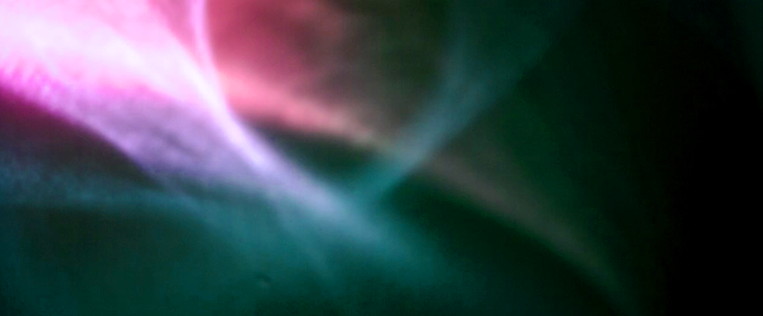

Survey of Alternative Displays
Blair Neal – www.blairneal.com - 2016
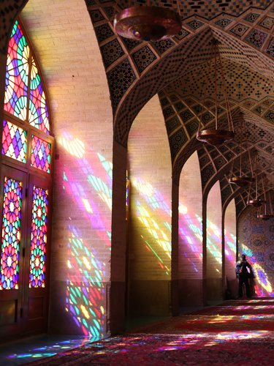
Stained Glass Example - Source
An artist has a large range of ways they can display their work. Cave walls gave way to canvas and paper as ways to create portals into another human's imagination. Stained glass windows were early versions of combining light and imagery. Electronic displays are our next continuation of this same concept. A photon is emitted; it travels until it reflects off of or passes through a medium. That photon then passes into your eyeball and excites some specialized cells - when enough of these cells are excited, your brain turns these into what you perceive as an image.

However, standard computer monitors, LED video walls and projection screens offer only a small glimpse of the range of possible visual illusions. Any traditional display can be augmented or used in an unusual way. New displays and technologies are still being actively developed and researched. Some content is suited precisely to being shown on a standard display, like a webpage. Other content is better suited to a space that exists beyond the screen’s surface and enables a sort of suspension of disbelief that this thing is really there. We continue to find new ways to construct the image of new destinations within the eye.

Knowing the range and limits of these different displays is similar to a painter really understanding their choice of paint and surfaces. Spray paint behaves very differently than oil, watercolor or ink. Drying times, color depth, texture, reflectivity, ability to blend colors - these are just some of the characteristics the painter must consider when choosing a medium for their new work. The textures of canvas, concrete, metal also impart a particular surface aesthetic. The same considerations can be a part of a digital artist's practice when they work with displays.

Additionally, musicians use what is called extended technique to explore the absolute limits of what sounds are possible with their instrument. Mastering an instrument with classical training is one dimension. Extended techniques demonstrate a deep understanding of how these devices function and respond to human input. Things that may sound like mistakes at first can be honed into highly expressive new tools. Violins can be made to sound like cellos with the right bowing method. Video and film artists like Nam June Paik and the Vasulka's have been exploring extended techniques for displaying video since their inception - but it is important to continue this tradition. There is still much to discover.

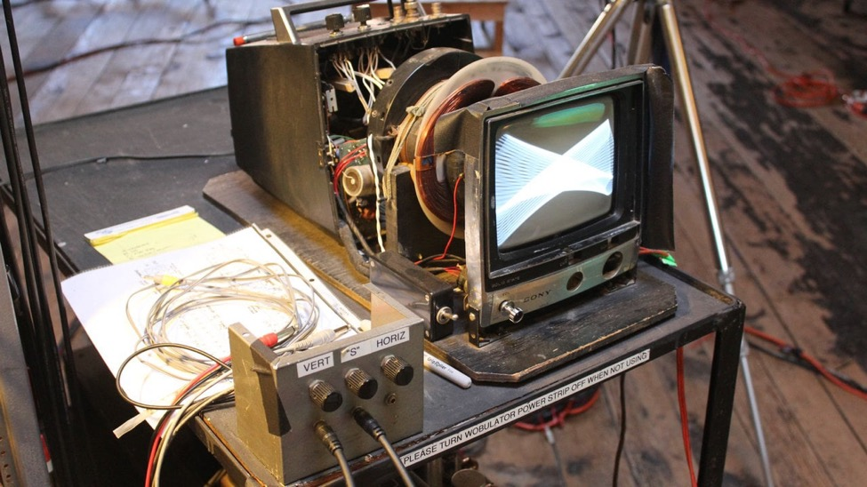
Nam June Paik's Wobbulator – Video Link
The purpose of this article is to collect and consolidate a list of these alternative methods of working with displays, light and optics. This will by no means be an exhaustive list of the possibilities available - depending on how you categorize, there could be dozens or hundreds of ways. There are historical mainstays, oddball one-offs, expensive failures and techniques that are only beginning to come into their own.

This document will hopefully serve as a reference for artists who are curious about pushing their content outside of a standard screen. Some implementations are incredibly practical and achievable on small budgets, and some require very specialized patented hardware that only exists in a lab somewhere. It is important not to get bogged down in the specifics of the technology, but to recognize that these all exist on a spectrum of information transference that employ light, medium, and brain. By keeping things in these simple terms, you are free to mix, match and re-appropriate to tell new stories.

Contents
- Notes on Standard Video Displays
- Brief Note on Holograms
- Pepper’s Ghost
- Projection on Static Transparent Materials/Scrims
- Projection on Water or Fog
- Volumetric Projection
- Transparent LCD/OLED
- LCDs with modified polarization layers
- Volumetric Displays (Mechanical/Persistence of Vision)
- Volumetric Displays (Layered screens)
- Electronic Paper
- Flexible Displays
- Laser Projectors
- Head Mounted Displays (VR/AR/Mixed Reality)
- Plasma Combustion
- Physical/Mechanical Displays
- Appendix and Other References

Notes on Standard Video Displays

It is worth discussing a few notes about the standard displays that most digital artists use. Many of the other things discussed in this article aren't standalone technologies, but rather techniques that modify or adapt pre-existing technologies into new applications. Each of these technologies could fill several books, so we'll just touch on some relevant bits.
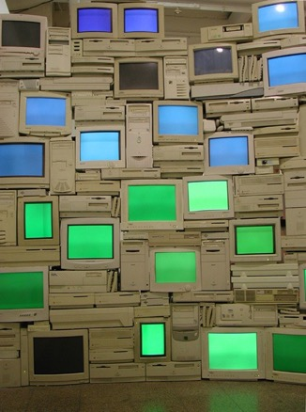
Standard Monitors

These can be a range of different technologies. Cathode Ray Tubes or CRT displays were common up until about 2005 but are difficult to find these days - they do have a lot of unique properties (not necessarily good ones...) that aren't available in many standard modern displays. Right now, the most common display is the Liquid Crystal Display or LCD and it is in most laptop screens, desktop monitors, commercial TV's and so on. LCD's have a backlight, a rear polarizer, a glass layer with electrodes and liquid crystals that react to electrical changes, and a front polarizer. Each pixel has a set of 3 sub pixels with red green and blue color filters that can be combined at different levels to recreate their millions of colors. Things like Quantum Dots are on the horizon to further improve LCD's color reproduction and accuracy by allowing more precise tuning of light wavelengths. Plasma displays were contender for LCD for a while, but they have become less popular. Pixels in plasma displays are individually lit which result in a deeper contrast compared to LCD's. Organic Light Emitting Diode displays or OLED displays operate in a similar principal to Plasma and have started to become more and more common. OLED has a lot of interesting properties since it can be made smaller and thinner than LCD or Plasma, this means that flexible displays and transparent displays are a much more viable option with OLED. OLED is still quite expensive in comparison to LCD’s at the moment, but this will change as the market shifts. MicroLED is another technology that works in a similar fashion but is still very new.
Sandy Smith’s Green/Blue Horitzontal

Standard monitors are affordable for most applications, are high resolution which makes them ideal for applications when the view is standing up close, have a decent color and dynamic contrast range, accept a variety of inputs, and are long lasting. Their brightness is suitable for primarily indoor applications. Brightness of these is generally measured in nits or candela/sq meter - most laptop screens are around 300nits at maximum. For outdoor applications, you have to source specially made outdoor monitors that are weatherproof, can withstand a variety of temperature fluctuation, and have a considerably higher brightness rating - some available ones can do 1500nits or more which would be almost painful to look at in an indoor setting.

Of course, these displays have their limitations. They are only viable up to a certain size for a single unit. Most of the largest max out at 120in or 305cm of diagonal image. Past this, they must be tiled together to form a larger video wall, and there are inevitable lines or bezels between adjacent units. Even those larger video walls start to reach a limitation at a certain point where Projectors or LED video walls are a more economical choice. The color and dynamic range of these monitors appears to be decent, but it is actually not as good as you might expect - we are missing out on a whole range of visible colors. Most standard displays are also locked at 60hz refresh rate (the speed that the screen is redrawn every second) which is perfectly fine for most applications like movie watching, but things like gaming monitors have started jumping to 144hz or more. Even though our brain's visual refresh rate is about 60hz (a huge oversimplification), there are some intriguing things that can be done with a higher refresh rate. Imagine scrolling this page up and down and having it look as natural as a piece of paper moving up and down instead of the commonly jittery experience. There are also researchers looking into using high frame rate or high temporal resolution displays to do things like turning normal displays into higher resolution displays - here is an incredible survey of computationally augmented displays. Consumer displays are also typically two dimensional and flat, even if displaying 3D content with glasses or another method.

Projectors

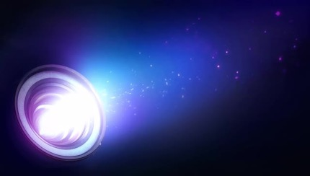
I have covered projectors in depth in another article so I won't go into detail with them here. It is important to remember that they are not much more than a fancy implementation of a light source, an imaging element and a lens. They are best for darker environments, but they tend to be the most economical choice for large scale imagery. It is also easier to blend multiple projectors together more seamlessly.
Image Source

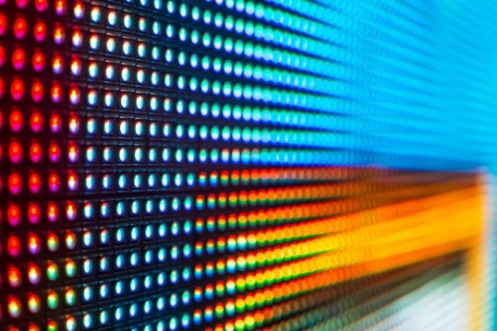
LED Video Walls

LED Video Walls are another common option for displaying digital art on a large scale (also called LED Displays - not to be confused with LED monitors where the light source is simply the LED backlight). These are usually comprised of individual tiles that are linked together and driven by a special display driver box that addresses the tiles from a standard monitor input. The tiles are generally either single all-in-one RGB LED's or larger individual red, green and blue LED's that are placed close together. The primary spec of an LED wall is its pixel pitch, measured in millimeters. If you are viewing a wall close up, you want a low pixel pitch - some of the lowest available are around 1.6mm. Larger pixel pitch like 16mm to 20mm is perfectly acceptable if your viewer is really far away from the screen because their eye won't be able to discern individual pixels as easily. LED walls are also one of the only display types that can be viewable in direct sunlight. Some of them have brightness ratings of 5000 or even 10000 nits, which explains why they are the display of choice in places like Times Square.
Image Source

They have a wide variety of models and applications. Some are used as jumbotrons in stadiums, as high end storefront signage, or are used as sculptural stage elements. Some move towards the spectrum of lighting elements and are extremely high pixel pitch. These large pixel pitch tiles can be used almost as "transparent" elements because when the audience is far away, they are able to see through the frame – as in this video wall. Stage lighting examples are the LightSlice, Vanish, and the Saber. Some manufacturers also provide custom LED tile work and can do more unusual shapes like spheres or triangles.

The primary drawback of LED walls is cost, although the prices have been dropping rapidly in the past few years as these become more commonplace. Finding price points for certain elements isn't usually publicly available but it can cost around $2000 for an individual tile and the driver box can be $5000-10,000. Most LED walls are typically rentals due to the large cost of purchasing them. They do last a long time in the case of purchasing, but even a modest sized wall at a high resolution can run into the hundreds of thousands of dollars very quickly. The cost of installation (for rental or permanent) can also be an additional hurdle since you typically need an experienced technician to set them up and get the pixel mapping established. They also have a particular aesthetic that is suited to viewing from far away. Up close they can be uncomfortably bright, and their pixels can be a distraction. Some stage designers will overlay a black or dark grey rear projection material or even acrylic overtop of the LED’s to soften them and provide a more diffuse look.

Brief Note on Holograms
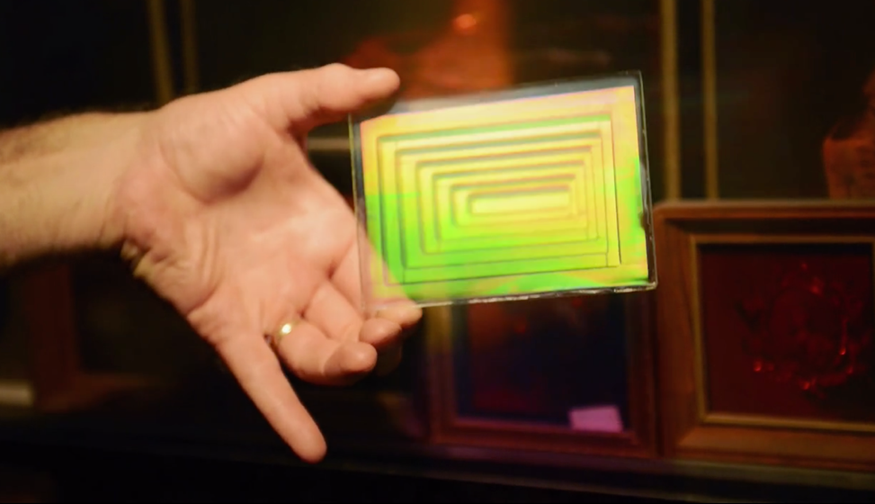
Image Source

To get this out of the way early, It should be mentioned that none of the displays mentioned below are in line with the definition of a hologram. A hologram is closer to a photographic medium as it captures an imprint of the light waves that bounce off an object. Most of the media headlines these days with the word "hologram" are typically talking about simple optical tricks or AR. Holograms have taken on a cultural meaning that differs from the scientific definition, similar to the cultural rebranding of "synesthesia" or "literally." This article by Oliver Reylos has a concise summary of what is considered holographic and what isn't. In his words:

When viewing close-by objects, there are six major depth cues that help us perceive three dimensions:

        - Perspective foreshortening: farther away objects appear smaller
        - Occlusion: nearer objects hide farther objects
        - Binocular parallax / stereopsis: left and right eyes see different views of the same objects
        - Monocular (motion) parallax: objects shift depending on how far away they are when head is moved
        - Convergence: eyes cross when focusing on close objects
        - Accommodation: eyes’ lenses change focus depending on objects’ distances

Almost all of the displays or techniques in this article have some holographic properties like parallax or multiple viewing angles, but are primarily in a class of their own. Would you call an oil painting a sculpture?

Pepper’s Ghost
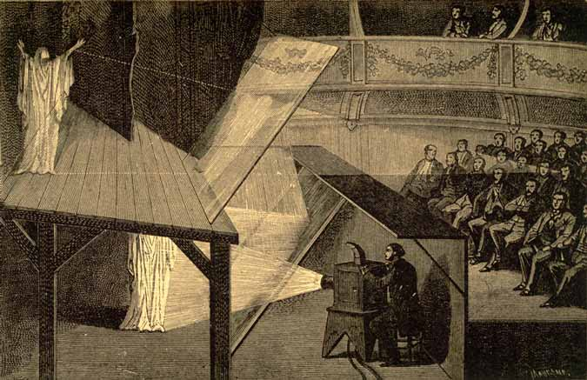
Image Source
Pepper’s Ghost is a classic illusion – it has been around for over a century and is still making headlines. 99% of the time, when you see a headline with the word "hologram" it is talking about Pepper's ghost.

Historically, the effect comes out of Phantasmagoria, a fascinating tradition of theater illusions that were developed in the 18th and 19th centuries that frightened audiences with never before seen images of spirits and floating otherworldly beings. The Magic Lantern is another one of these early theater effects and it is one of the earliest forms of the projector. The name Pepper’s Ghost comes from John Henry Pepper who popularized the effect in the mid-1800’s with his friend Henry Dircks (who arguably developed it before Pepper). However, the illusion was first described in the 1600’s by an Italian scholar named Giambattista della Porta in his book Natural Magic:

Wherefore to describe the matter, let there be a chamber wherein no other light comes, unless by the door or window where the spectator looks in. Let the whole window or part of it be of glass, as we use to do to kee out the cold. But let one part be polished, that there may be a looking glass on both sides, whence the spectator must look in. For the rest do nothing. Let pictures be set over against this window, marble statues, and suchlike. For what is without will seem to be within, and what is behind the spectators back, he will think to be in the middle of the house, as far from the glass inward, as they stand from it outwardly, and so clearly and certainly, that he will think he sees nothing but truth. But lest the skill should be known, let the part be made so where the ornament is, that the spectator may not see it, as above his head, that a pavement may come between above his head. And if an ingenious man do this, it is impossible that he should suppose that he is deceived.
Pepper's ghost is incredibly easy to implement. The simplest version involves a transparent reflecting surface (a sheet of glass, plastic, or a half silvered mirror), and an image source (a monitor, projection screen, or a lit source). There are two versions of this effect that are commonly used - the classic one from the 19th century typically involves two separate physical spaces and specialized lighting. The modern version of Pepper’s ghost involves a digital screen (monitor, or projected image) and a half silvered mirror or specialized film designed to be invisible to the viewer. This version is also used for teleprompters where the camera lens is positioned behind the mirror facing the speaker. Both are essentially the same in principal.

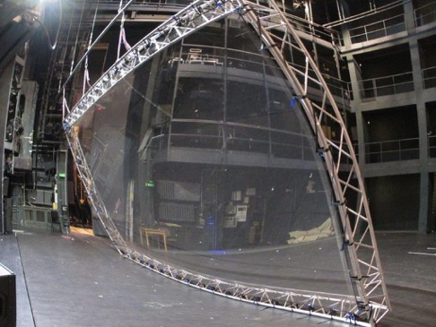
Glass mirrors are the most accessible way to achieve this effect (it can even be done with reflective plastic and a smart phone), but at a certain point it becomes difficult to scale the glass to be large enough. For stage productions, there is specialized plastic film that can be employed to reflect much larger surfaces. Musion is the primary company that comes up while searching, and another is Arena 3D. It is worth noting that Musion claims a patent on a version of this 100+ year old technology and has hit "imitations" with lawsuits in the past. It is also easy to source your own film from 3M or other sources in Asia – another version of the film is manufactured by DuPont.
Image of reflective foil setup for stage production - Source

Carefully controlled lighting is essential for this effect to look its best. The source of the image must be bright in comparison to the surroundings behind the transparent surface. The observer should also be in a very dark space so their own reflection doesn't show up in the mirror. It is also helpful to have something slightly visible behind the transparent surface so that your floating image has something to float overtop of and give the viewer the parallax depth cue. The effect can be striking if combined with props behind the mirror - like a person sitting on a chair or animations that swirl around an object. However, there are limitations to this depth effect.

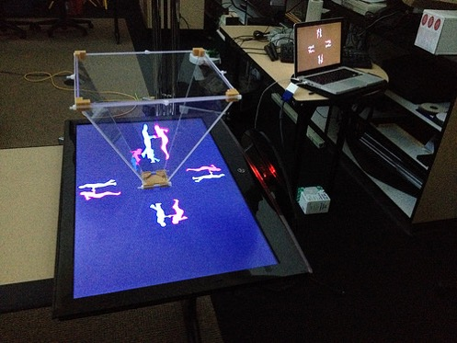
Peppers ghost is still very much a 2D effect and does not present an image in three dimensions. It is just a mirror reflecting another flat plane. Parallax between the reflected image and the background is what gives our eyes the illusion of the content floating in mid air. A false sense of 3D can be achieved depending on your source and how the reflecting surfaces are arranged. There are some implementations of the effect that put 4 mirrors in a pyramid shape under a monitor (some have marketed themselves as holograms - sparking controversy). By having the monitor display a different image for each mirror, the observer gets more of a 3D view as they walk around - even if it is just 4 discrete viewing angles. Head or eye tracking would have to be employed to make the effect a little more immersive, but then it would only work for one observer at a time. As it usually functions, the effect may look best from one vantage point, especially if you are trying to align it with an object behind the surface. This misalignment can be minimized by having your observer be further back so when they move their head, the parallax isn't as great as if they are right in front of the screen.
Pepper’s Ghost Pyramid - Source

Projection on Transparent Materials and Scrims
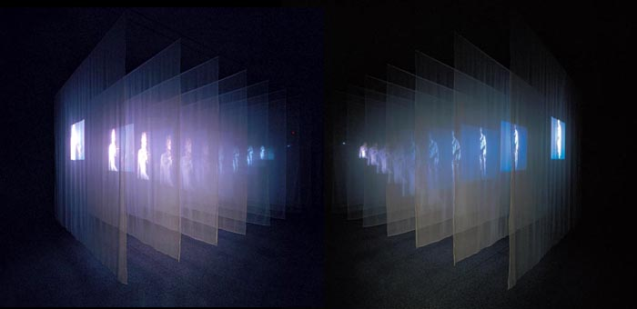
Image of Bill Viola’s The Veiling - Source
Projecting on semi-transparent materials is essentially a variation on the Pepper's ghost illusion. It is also an effect that has been used in theater for a long time. In contrast to Pepper's ghost, this technique uses a transparent material to catch (not just reflect) the light from a projector. The viewer can still see through the material, but the projected light is scattered and appears to be transmitted from the material. Viewers can still see through the material allowing for a depth effect from parallax, but the illusion is still flat and two dimensional.

The implementation of this technique is one of the cheapest and most accessible on this list. You will need a semi transparent material and some means of projecting an image. The material you use depends on the scale or size of the end result and the type of effect you are going for. You also must consider whether you want to use front or rear projection. Rear projection (with the viewer facing the projector lens) will produce a noticeably brighter hotspot depending on the material used and where the projector is, and front projection means the image will spill behind the surface a little bit which may result in some doubling.

As far as materials to use, on a small installation you may be able to get away with just a piece of fabric like tulle or netting - things like bridal veil material. White fabric will catch and transmit light the best, but sometimes black can still work and give you a similar effect with the fabric appearing more "invisible."

If you are trying to have an image appear on a storefront window or piece of glass, you will need a specially engineered film that is nice and transparent but still collects a lot of light from your projector. The proper film for glass can be very expensive for large pieces, so keep that in mind. One source has the material for roughly $1200 for a piece that is 2.2m by 1.2m. Here are some possible vendors for this kind of film: [One] [Two]. You can get away with cheaper materials, of course, but the effect may be very different. Cheaper or DIY material may be either more opaque (yielding a brighter image but less transparency) or too transparent (yielding a faint image). Projecting on glass will certainly show something if there is significant dust on it, but the effect will be very dim.

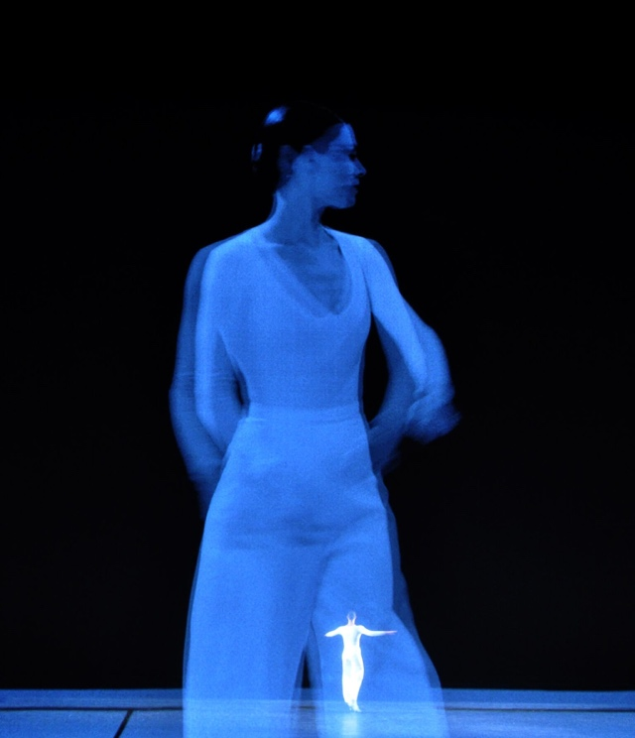
To achieve much larger images for theater or stage, fabric is the most economical choice for a scrim. You can get very large seamless swaths of fabric for the purposes of stage projection. Some fabric will have larger holes in its netting which will make it more transparent but will also cause your projected image to be less bright as well, in addition to dropping the sharpness and fidelity of the image. Here is a great resource for more info on stage scrim projection materials, including silvered fabric. You can also layer these materials to get several planes since the light is passing through. The cone of light from the projector will cause the image to be larger or smaller on each depth layer depending on whether you are projecting from the front or the back. You can also only go so far with layering before your light runs out or just gets out of focus.
Lucinda Child’s Dance – using scrims for projection

Similar to the requirements for Pepper's Ghost, this technique requires very controlled lighting. You will need to balance the ambient light that is hitting your fabric so you can preserve the illusion of a floating image - otherwise it can just look like a standard projection screen that you can see through. Contrast is key here. It also helps to have the space behind the image not be completely dark to give the image more dimension. If the viewer can see things behind the projected image then they get the layered effect and the sense of parallax that helps it appear more 3D even if it is still just 2D.

Content that works best on any of the semi-transparent materials tends to be imagery that does not fill the entire projected rectangle. The optimal approach is to have your content sit on a field of black, so that that it appears to have no bounds. A vignette or feathering on the edges can also help if you have elements that enter and exit from the sides, otherwise the viewer will see harsh edges. Semi transparent material also causes the projections to have a slight glow to them - the light beams get slightly diffused when passing through the material which tends to soften the sharpness of the image a little bit.

Projection on Fog or Water

For this technique, instead of a static material like cloth, you can use water, haze or another atomized fluid to catch light and provide a semi-transparent screen.

Water Screens
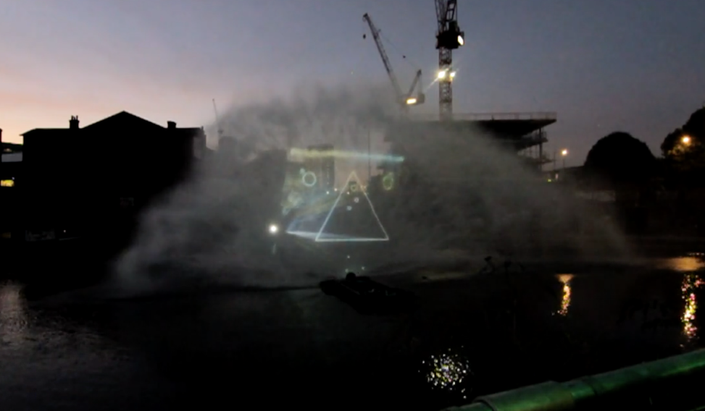
Still of X by Max Hattler – Video Link - https://vimeo.com/49029399
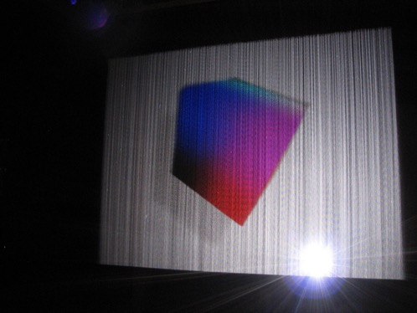
There are two types of water based projection surfaces - either the water is moving upwards or falling downwards. For an upward blast, these rely on a high powered water jet and a special attachment that spreads the water into a large flat half circle screen of water and mist. The size of the screen is limited by physics and the power of the water pump - most companies can generate screens that are in the range of 20-30m wide and about 6-10m high. This mist is then usually hit with rear projection by a high powered projector. This results in a semi transparent screen that can be hidden or revealed at the flip of a switch in the middle of a body of water.

Falling water screens are much more manageable to install indoors. These have a mechanism that just pushes water through spaced out nozzles on the top piece and collects and recycles the water in a basin on the bottom. Some systems are even able to selectively open and close the top nozzles to allow water to fall in different ways.
Falling Water Screen Example - Source

The effect of water screens is very unique due to the haze of smaller water mist particles causing a halo and giving the 2D image more volume. There is also a textural quality to the water and mist that you should plan on, as it can add some glow and reduce sharpness a bit. Rear projection works best on these screens, so there will be a persistent hotspot behind the content, but this may not impact too much depending on your setup. Front projection is possible, but you run the risk of doubling the image onto other surfaces behind the semi-transparent screen.

Fog Screens/Laminar Flow
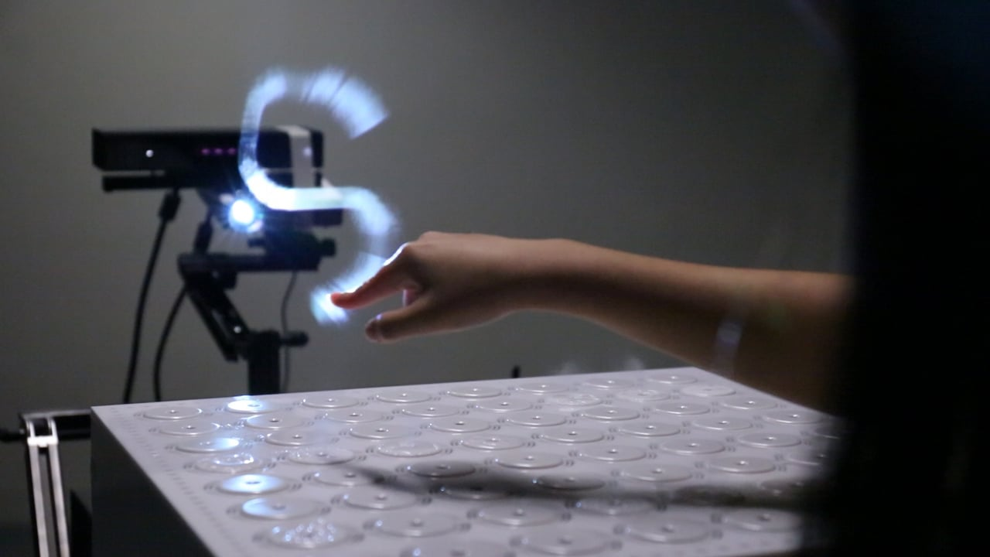
Image Source
These screens rely on a steady controlled flow of haze or water mist to create a thin layer of semitransparent fog that can be rear protected. A series of valves directs the mist into a narrow sheet, and the projected light is refracted off the particles. The haze can be water or oil based.

This technique works best indoors because of minimal air currents and the light contrast needed for the best illusion. Due to physics, this technique is limited by the screen size that can be created. A lot of commercially available screens can only get to something like a 2m by 1.5m size. The width can be extended with multiple mist units, but the height is the primary hindrance since the mist gets less dense after a certain distance from the valves and fans. Also, since this screen is so transparent, the viewer will get a strong hotspot from the projector and the content will shoot right through onto adjacent surfaces. Commercially available units are available, but aren't cheap – some are almost $20,000 or more. DIY options also exist, but require a lot of materials. Getting the haze production right in a DIY setup is probably going to be the biggest challenge since most fog machines tend to accumulate in an enclosed space rather than dissipate.

Volumetric Projection

Volumetric projection is a technique that is a much more technical application of projecting into a thin sheet of fog. Instead of having light come from a single point, it uses multiple light sources or specialized optics. By combining these sources with the additive quality of projected light, this technique is able to create dimensional images with multiple viewing angles. There are a few scientific papers out there on similar processes, and we'll discuss laser plasma displays later on that share some characteristics.

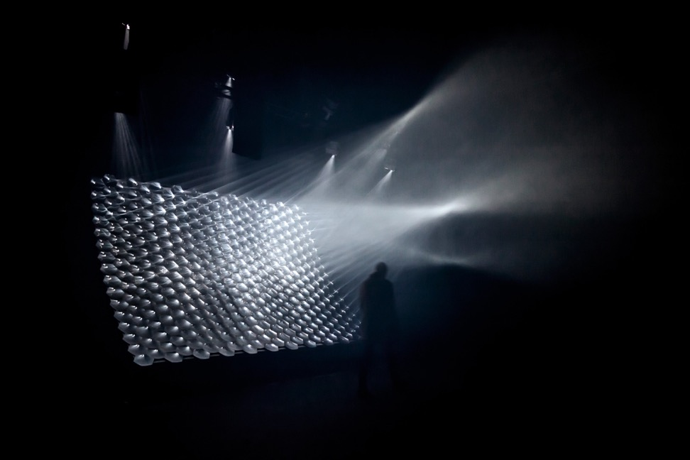
Image of Light Barrier by Kimchi and Chips - Source
Light Barrier by Kimchi and Chips is likely the first piece to use this technique. With Light Barrier, the artists project images onto an array of parabolic mirrors. Using custom software that analyzes where the pixel’s light ends up after hitting the curved mirrors, they can approximate the path of light from each projected pixel. When this is done for the entire array of mirrors, they can calculate where in 3D space each pixel path intersects another after hitting the mirrors. The projection area above the mirrors is filled with haze from a fog machine - the medium for these intersecting light beams. If more beams illuminate a particular location in 3D space, then that spot will appear brighter. By hitting several of these overlapping spots together, the combined focal point becomes brighter, and images can be formed in the haze. There are other ways to achieve similar variations on the effect that involve multiple projector sources, but this gets logistically complex and expensive very quickly.

This technique currently has its limitations. Making recognizable images requires a calculation engine and custom software, meaning you can't just drop in any content and have it show up in 3D. The workflows for generating content based on depth maps are improving, but there is also going to be an upper limit to how fine the details can be. It may take several dozen converging pixels to make a recognizable voxel - so once we have higher resolution projectors we might be able to put together even more complex visuals. Full color projection with this technique is also a challenge because the overlapping colors would add together and change the colors for different viewing angles. White is also going to show up the best for an effect that is already going to be slightly faint compared to other projection methods. Nonetheless, it is an exciting area of discovery and still has a lot of potential to explore.

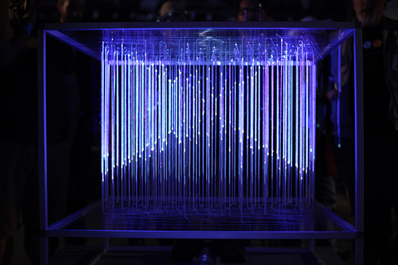
There are also variations on this idea that don't involve fog or specialized optics. A simple way is to use layers of fabric - the image will be the same on each layer but will get larger or smaller on each pass. There is also the method employed by the Lumarca where a grid of thin strings are stretched to make a large volume. Each string in the volume can then be precisely mapped by a few columns of pixels from the projector. When the location of each column is then mapped to a known 3D space, it becomes easy to render simple graphics on the array of strings that appear to have volume. The strings transmit the light a bit, so it is easy to see from all sides. This method also has some density and fidelity limitations but is also easy to scale.
Lumarca Image - Source

Transparent LCD and OLED
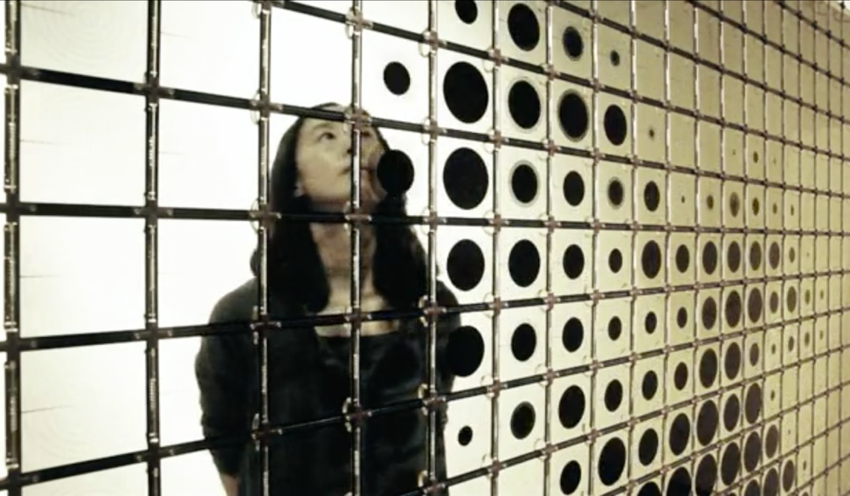
IRIS by HYBE – Video Link

LCD’s are a transmissive technology (in contrast to Plasma or LED that are emissive technologies). This means that light passes through a medium to get to your eye. The backlight that is used for LCD’s is meant to provide a strong and very even field of light that gets passed through the actual liquid crystal/polarizer element. Essentially, the backlight is a flat light box that you can fade up or down, but it doesn’t have much else to do with creating the image itself.

A liquid crystal element can function perfectly fine on its own, without a proper backlight. This means that an LCD can effectually work as a transparent monitor if you are keeping some sort of light source between the screen and the viewer. Using an LCD this way yields a lot of interesting possibilities.

A common usage is to put an object in a box with a strong, even light behind it, and have at least one side of the box be a transparent screen. This allows you to superimpose sharp graphics that appear to float overtop of the object inside. This can be combined with a standard touch screen for interactive transparencies. Also, since LCD's do such a good job at blocking light, when they are displaying black they are nearly impossible to see through, providing a unique reveal effect. A bright point light source can be put behind them to use the LCD as a sort of projection mask - resulting in a variation on a normal projector (your projected image will probably be fuzzy without focusing lens elements though).

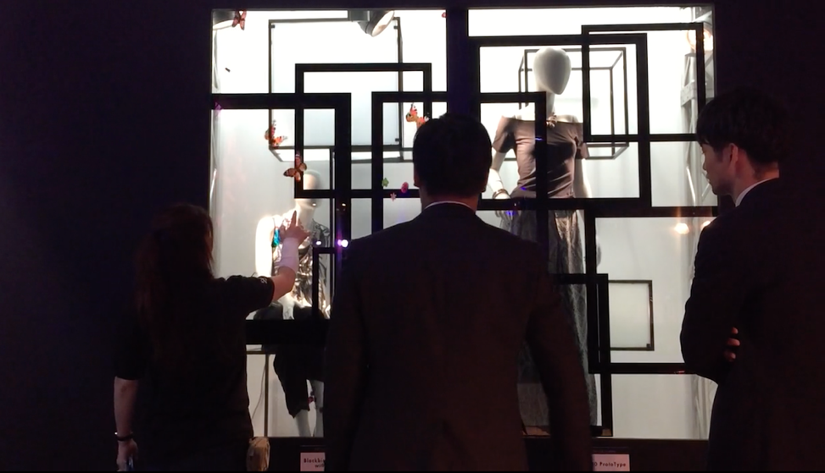
80” Transparent LCD Demo Video - Link
Some artists and studios have also been able to source custom LCD elements that are closer to the LCD's that are used in old pocket calculators with only a few elements that can be turned on and off. Pieces that come to mind are Hypersonic's Patterned by Nature and Iris by Hybe.

A challenge with transparent LCD's is sourcing usable ones. There is the DIY route, which I cover a little bit in the appendix – but the visual results aren’t great. Only a few commercial vendors supply these screens, and because it is a specialty item, they tend to be more expensive than comparable screens with backlights. You may also be limited by certain available sizes – making it difficult to scale these to a large application. Even if the screens were tiled together, at least one edge needs to have the driver board on it, so its not as easy to tile them together like normal LCD walls. The color reproduction with these tends to be a little duller than the vibrant colors you're used to. Their transparency can be cloudier compared to regular glass since the polarizer and liquid crystal layers are sandwiched in there as well. I’ve found that black, white and gray content is the most striking on transparent LCD’s.

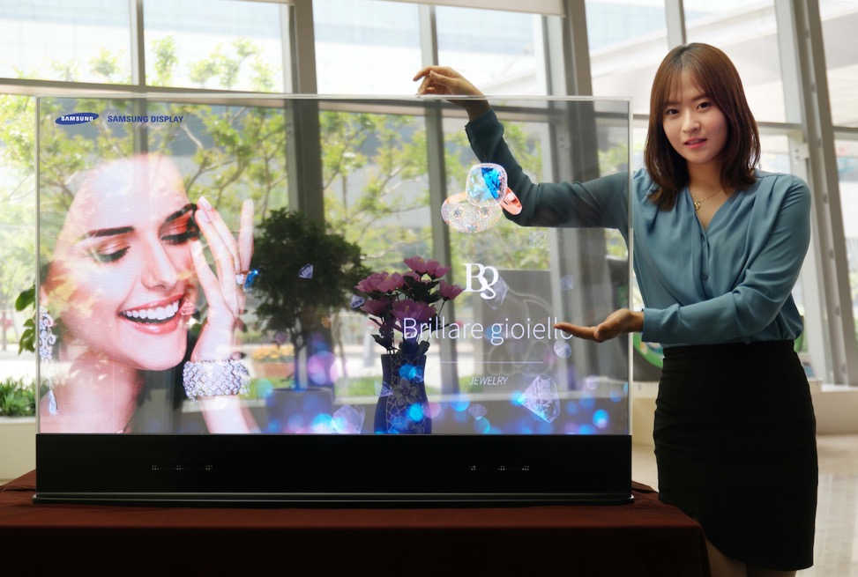
Samsung’s Transparent OLED - Source
Transparent OLED's, however, are a different beast. OLED is an emissive technology and therefore does not require a backlight. This means that brightness and color reproduction will be much better. These displays are still somewhat hard to find, but their popularity appears to be increasing. Their brightness still isn't going to rival a normal display, so don't expect to use them outdoors or in a brightly lit space. Also in contrast to a transparent LCD that works equally on both the front and back, for now transparent OLED is better on one side since the emissive element is designed to point in one direction. They are still very useful for a lot of creative applications like being applied to a storefront window without blocking the view or applied onto a mirror so that graphics can be superimposed on top of the mirror. They are also the future of flexible displays - discussed in a later section.

LCDs with Modified Polarization Layers
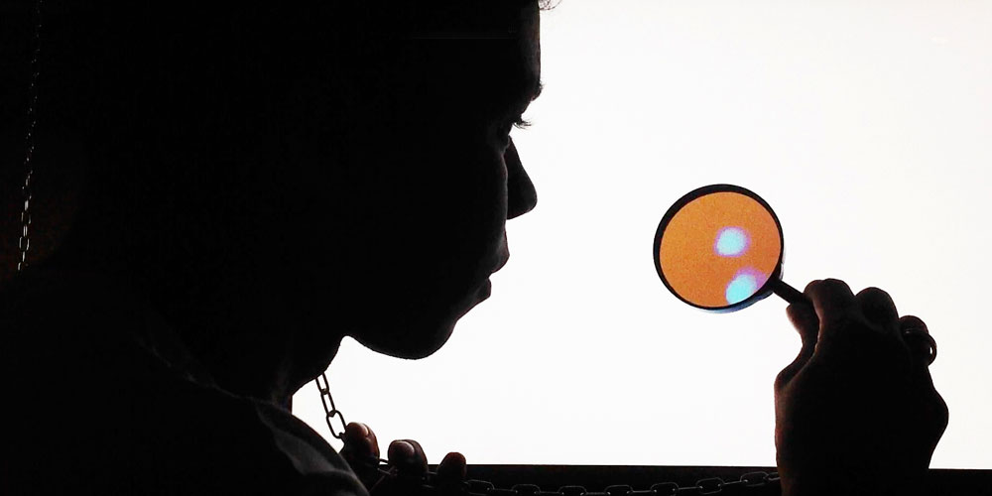
Karina Smigla-Bobinski’s SIMULACRA - Link
Besides being turned transparent, LCD's have another trick up their sleeve involving light polarization. By removing one of the polarization layers, the screen will look white to a viewer until they look through another polarizer. Below, I'll attempt to describe how this works.

A full explanation of the science behind wave polarization is a little bit outside of the scope of this article, but there are some links in the references section as the end of the article. This video is a pretty solid explanation of polarized light and its usage with cameras. I encourage you to look into it because there are a lot of other great effects that can be employed via polarization. My explanation will be simplified in order to stay concise.

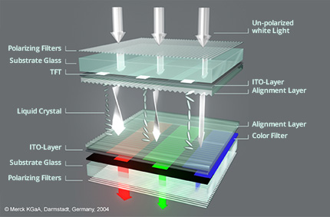
LCD Structure – Image Source
You may remember from Physics class that light sometimes behaves as a particle, and sometimes as a wave. This light wave has a frequency, an amplitude and a rotation or polarization. As stated before, an LCD works by employing a backlight, a pair of linear polarizers, and a liquid crystal layer. When all of the light particles come off the backlight, they do not have a uniform polarization - they are just going all over the place. As they pass through the back polarizer, specialized molecules embedded in thin columns absorb any light that doesn’t have a particular polarization. The polarized light then passes through the liquid crystal layer. When the liquid crystal receives current, its molecular structure changes and it provides a transparent tunnel that can be variably twisted. The twist in the liquid crystal gives us a way to electronically modulate the rotation of the light wave.

As the light exits the liquid crystal and arrives at the front polarizer - this is where the magic happens. The front polarizer is the exact same material as the back polarizer, but its physical orientation is perpendicular to the back polarizer. This offset orientation effectively blocks or absorbs light of a particular polarization. If the light passes through the liquid crystal without being twisted, you will get a black pixel. If the liquid crystal twists the light 90º so that it passes through the front polarizer - you will get a white pixel. With the red/green/blue color filters on each pixel, the video signal is able to tune the wave orientation passing through each color to produce the millions of colors we see on an average display. Again - this is a very simplified explanation that glosses over a lot of important details related to different LCD technology.

So with all of the above in mind - if we remove the front polarizer, what happens? Now there is nothing to absorb the light that passed through the front polarizer and the viewer will just see white light. If you put a polarizer back in front of the screen, everything will appear normal again. This polarizer doesn't need to be right on top of the screen either. The polarizer can be in glasses that the view puts on or it can be placed meters away from the screen.

There are a lot of interesting possibilities available for these screens, but actually getting one to try is another matter. See my notes in the appendix on how you might make one yourself from an existing LCD.

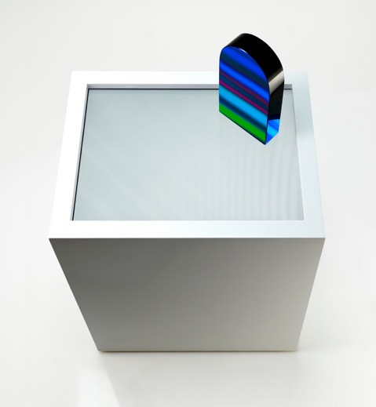
This technique is great for an unusual reveal to the viewer since it just looks like a white screen otherwise. The polarizing film can be placed at any distance from the screen and still allow the screen content to be visible, as long as the film is between the viewer and the modified LCD. You’ll notice that depending on the way that the film is rotated relative to the screen, you can get things like inverted or warped colors since you are blocking different orientations of light. Also, due to the properties of polarized light, the content can be seen via the reflection off of other objects, or if you stick the polarization film on top of a mirror. The artist Flavien Théry has some amazing pieces that employ modified LCD’s and polarization film. In his piece La Porte he has a small door shaped object made of reflective material on top of a modified screen and the content is only viewable through the reflection on the door.

Unrelated to LCD's, light polarization is also a technique that can be used with projectors as well. Many 3D movies in cinemas have different systems to pass the light through a polarizer (either dual projectors with separate polarizers, or a spinning polarizer in sync with the framerate). To preserve the polarization of the light, many of these setups also require a specialized silver screen material or paint. The view is usually given either passive (each eye has a polarizer in a different orientation) or active glasses (which shutter each eye in sync with the projector) to ensure that each eye sees the image that is intended for it. I haven't found a good shareable example of polarized projectors being used in an unusual or artistic way, but there are definitely some possibilities out there.
Flavien Théry’s La Porte - Link

Volumetric Displays

(Mechanical/Persistence of Vision)
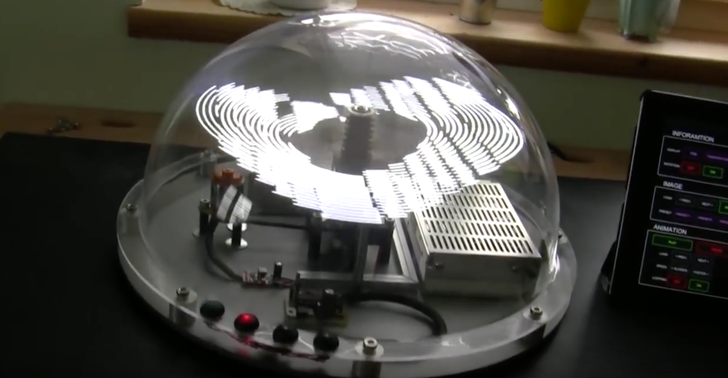
viSio Volumetric Swept Volume Display - Source
With Volumetric Displays, there are a couple different flavors, and in this section we’ll cover displays that work with the principle of persistence of vision, and are also known as swept volume displays. Volumetric Displays have been discussed in science fiction for decades and have been researched extensively since the 1960's. Here is a 1969 paper from Bell Labs on a technique that uses a loudspeaker to vibrate a reflective mylar sheet in sync with a CRT to make an image volume.

This type of volumetric display usually uses a 2D display element in addition to a mechanical apparatus to move the display quickly enough (either laterally or radially) to give the illusion of volume. You can buy persistence of vision (POV) LED toys at carnivals and festivals that are the same basic idea that is found in the more complex setups discussed below. Crayola even made a toy a few years ago called the Digital Light Designer that let kids draw on one of these displays in real time. There are also more sophisticated LED based setups such as the viSio or voLumen that are mentioned in the links section.

These volumetric displays allow for one of the best impressions of 3D physicality and presence because the viewer can walk around and view different angles of the same image. The downside is that their mechanical nature makes them difficult to scale to larger displays with finer resolution, and the fact that they are moving so quickly can make them quite dangerous in certain situations. Some techniques can also be difficult to capture reliably or smoothly on video because the refresh rate may be out of sync with the camera's frame rate.
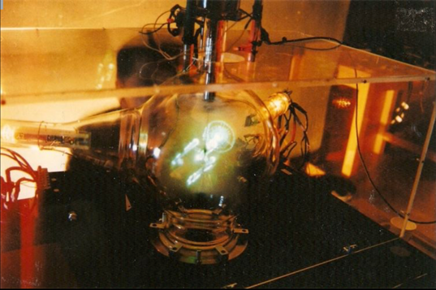
Barry Blundell’s Cathode Ray Sphere -Source
There have also been attempts at combining mechanical motion with more sophisticated displays like CRTs, projectors or LCDs. One of the earlier successful examples of these screens is Barry Blundell's volumetric cathode ray tube work. He did some experiments in the 1990's that used a specially designed glass tube, a spinning phosphor plate and multiple electron guns. Here is a video of that display in action.

The Perspecta by Actuality Systems came in 2001 and followed a similar approach, but used specialized projectors and a rotating screen instead of electron guns. Here are some stats on the capabilities of the early version of the Perspecta:

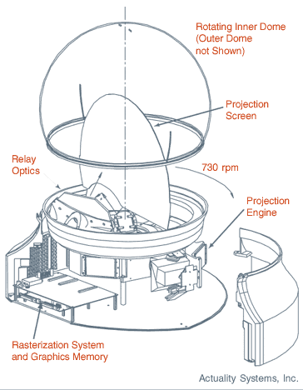
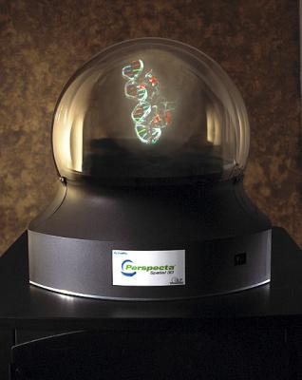
"This computation is performed on a high-end NVIDIA GPU within the Volume Rendering Unit, and the results are stored in the Core Rendering Electronics (CRE). The CRE drives three Texas Instruments DMDs (Digital Micromirror Device) at approximately 6,000 frames per second with these slices, which are projected onto a diffuse screen that rotates at 900 rpm. The result is a crisp, bright, 3D image that can be viewed from any angle.”[Link]
Perspecta Diagram - Source
Perspecta Display - Source

A more recent version of this type of display is the Voxiebox by VOXON. It uses a high speed scientific projector and a rear projection platform that is moved up and down extremely quickly. The movement of the platform, the refresh rate of the projector and the content that is being drawn are all synced together by software. As the platform moves, a different slice of a 3D image is projected. As these slices are projected, the viewer's brain assembles them into a persistent volumetric image.
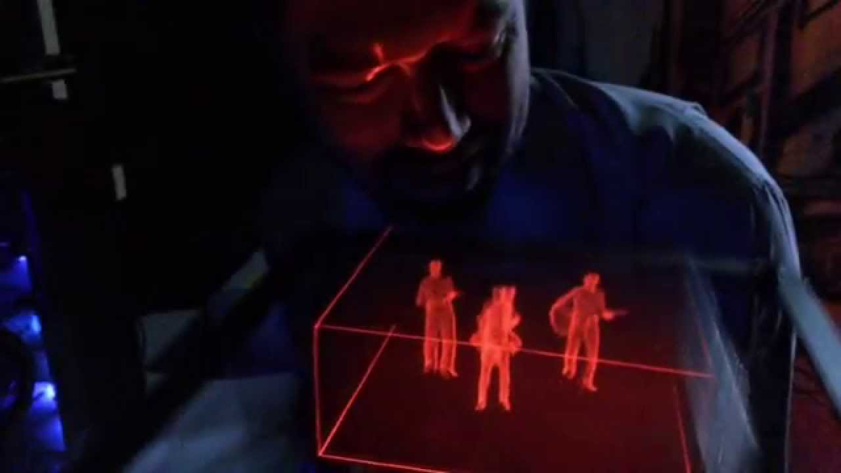
Voxiebox Image - Source
Currently the Voxiebox system has a perceived volume of about 25cm x 25cm x 12cm [author's estimate]. The Z axis resolution of the Voxiebox display is primarily limited by the frame rate of the projector and the lateral motion of the projection platform. There are also challenges with scaling this display to a considerably larger size for a number of reasons. Moving a much larger platform up and down a greater distance at a rapid pace isn’t outside of the realm of mechanical possibility, but it would be a different engineering challenge to make this display several meters wide and move up and down a few meters multiple times in a second. A larger platform also requires a brighter specialized projector, which comes at its own cost.

Perceptually, the Voxiebox style of display is suited to some particular visual aesthetics - it is better at showing certain types of graphics than others. The projected light is additive on each slice, so while one surface appears solid, it also combines with the light behind it - this is similar to the issues faced by volumetric projection in the other section. This makes very dense imagery move towards the white end of the spectrum as different slices add together for the viewer. Vector style imagery with points and lines tend to be more successful ways to represent solid shapes.

Another example of a mechanical volumetric display is Benjamin Muzzin’s piece Full Turn. He took 2 LCD panels, stuck them back to back and spun them at very high speeds. The power and video signals were passed in using a specially designed slip ring. The bottom ring is fixed and has one end of a cable attached to it. The top layer spins with the LCDs and maintains electrical contact via metal brushes that run in circular channels. As the LCD spins faster than the refresh rate of the screen, it allows it to render volumetric images that move and shift. In comparison to the Voxiebox, this particular implementation presents a different challenge when trying to form coherent 3D images because of the radial motion as opposed to lateral motion.

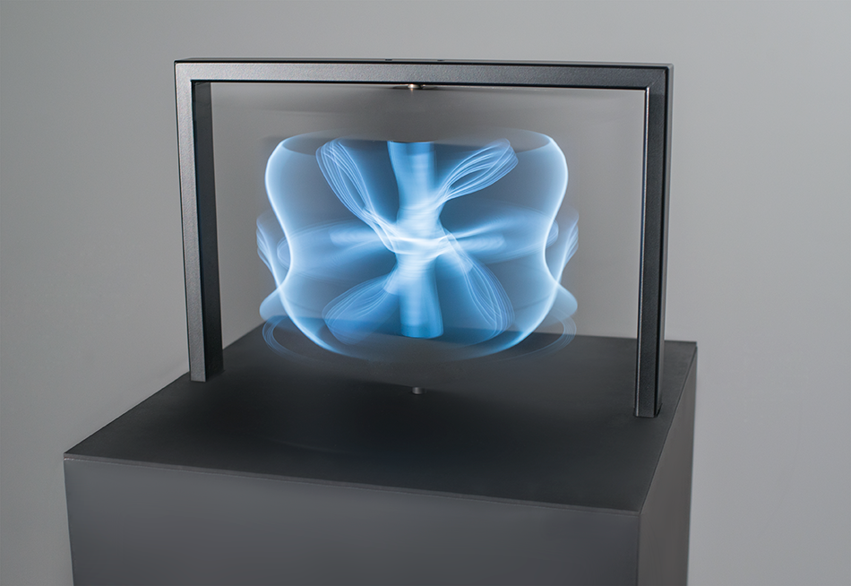
Benjamin Muzzin’s Full Turn - Source

Volumetric Displays

(Multiple Layered Screens)
There are a few different types of this type of volumetric display. One type is known as a Light Field Display or a Polarization Field Display and uses a series of layered LCD’s (or other transparent media) to create an illusion of depth via parallax. This is a simplified explanation because there are a lot of nuanced variations on this concept. The Nintendo 3DS is a well known version of this type of display - it uses 2 stacked LCD’s - the bottom one alternates dark bands so that each eye sees the version of the image that is intended for it.

By stacking each display on top of the other, you are able to create volumetric effects with 3 dimensional content, or more slipping parallax effects with 2D content. The depth resolution is limited by how many displays you can stack on top of each other. It also becomes more difficult to backlight all of the stacked displays so that everything is visible. Each display, its components and polarizing film will cost a little bit of luminance and clarity for the viewer. If the screens are far apart, there is also the possibility of internal reflection between two adjacent screens that can impact the contrast.

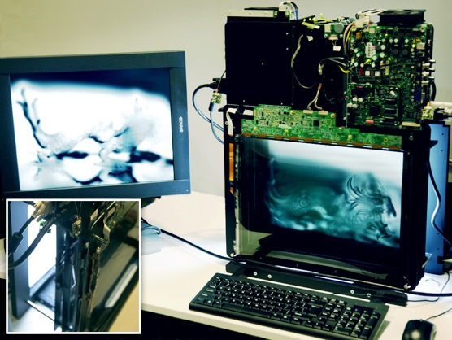
When using this type of display technique to show content, there are a few different approaches and challenges. The most straightforward method is to chop up your images into different depth layers so that you can achieve parallax by displaying each layer on a different screen. This is similar to the method of hand drawn cel animation where the background landscapes are on a different layer than the characters. To achieve more of a 3D volume effect with this method, you would have to incorporate viewer eye or head tracking into the display software in order to display multiple viewpoints in real time. The screens are also only viewable on 1 or 2 sides of a cube, instead of 4 or 5 sides. Your Z-dimension is constrained by how many displays you can stack on top of each other. Blending colors across multiple screens is also a challenge. Stacking dark colors will turn muddy at the end and stacking red green and blue won't necessarily make white as with other additive light methods. Color filters also impact the brightness, and some projects use grayscale monitors instead.
MIT Media Lab’s Polarization Field Display - Source

Getting a video signal to each display is another technical challenge, depending on how many layers you are trying to drive. If you have 6 stacked displays at 1920x1080 - you need to be able to render six 1080p streams at once and keep them all synced together.

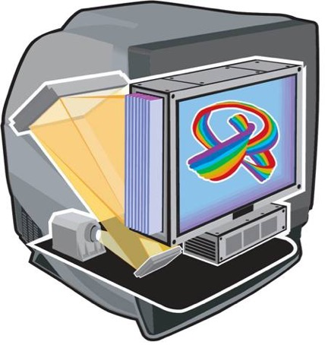
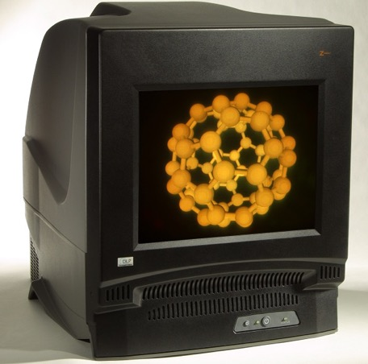
LightSpace Technologies has a display that was formerly known as the Depthcube that uses a high speed projector and a series of about 20 LCDs that are used as optical stops, so that each layer of depth can be halted at the correct location. By using special antialiasing techniques, the physical space between the layers can be smoothed so it doesn't feel so stepped. Here is a writeup with more technical details on how it works. This display has been in development since the early 2000s and has been commercially available at an unknown price point. The primary use case of one of these displays has been in engineering or medical applications. Here is a video of it in action.
Depthcube Diagram and Image - Source

There are some versions of layered screens or display volumes that don't stack multiple LCDs but combine them with things like layered Pepper's Ghost, multiple projections on scrims, transparent acrylic, or LED cubes. The Looking Glass Factory is working on a product called Volume - it releases this year and promises to be one of the most affordable and accessible options for multi-planar volumetric displays. There are also many pieces or products out there that use a 3D volume of individually addressable LEDs to create a layered volume with more viewing angles but a lower visual fidelity.

Electronic Paper Displays

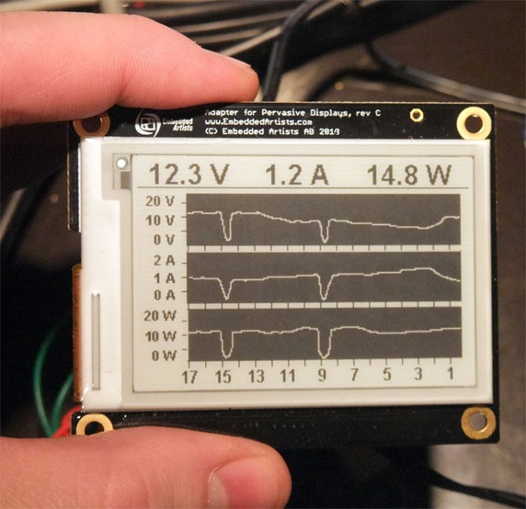
Electronic Ink Display Example - Source

Electronic Ink or Electronic Paper displays are still a relatively new technology and are mostly found in electronic readers. They have some unique visual qualities that set them apart from any other display in this list.

There are a few different kinds of technologies that are considered E-ink displays, but the common one is a monochromatic electrophoretic display. These work by suspending charged particles in a fluid. A top and bottom layer with embedded electrodes sandwiches this fluid layer, and when the charge changes on a layer, the ink particles are pushed to the top, or pulled to the bottom. When the black ink particles are on top, they absorb light and appear black, and when they are pulled to the bottom layer, that pixel appears white because it is reflecting more light.

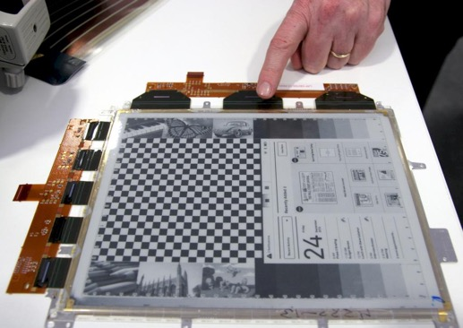
This display mechanism means that they do not transmit their own light (except in a few consumer models where a backlight has been added for night reading). Since they are only visible via light from the environment, this means that bright environments aren't nearly as much of a negative - and that makes them one of the only displays in this list that are viewable in direct sunlight. These displays are also incredibly low energy since they only use energy when changing the screen contents - without power, the screen would potentially hold its image indefinitely.
E Paper Display - Source

However, because of the way the technology works, the refresh rate of the screen is very low which makes it unsuitable for a lot of motion graphics. When the screen refreshes, there are also some ghosting artifacts that appear on parts as the ink particles reposition. Some screens will momentarily make all pixels black in an effort to normalize everything and prevent artifacts. Some screens can indeed refresh faster, at the expense of contrast and clarity artifacts. For more on the refresh rates of e-paper displays, check out this resource. They are also typically able to only display monochrome images or a certain level of grayscale - displaying color with these is still an application that is in development but much closer to a consumer reality. Other methods of creating e-paper displays with graphene are also being researched, with the added bonus that they have the potential to be flexible as well.

Making use of E-ink displays in artworks is unfortunately impeded by the fact that purchasing a standalone screen of a significant size is very difficult. A lot of e-paper screens are also made fairly small - usually less than 12in, so even if you could modify an existing e-reader display, it wouldn’t be very large. The consumer demand for these is primarily in e-readers so there is little incentive for the manufacturers to make screens that can be addressed as a normal video monitor with an HDMI input for example. Only recently have companies started producing and selling consumer models or development kits that connect via USB, but only in limited quantities. There are several e-ink development boards that can be addressed with a micro controller, but they are about the size of an index card or smaller.

Visionect is working on development kits for 32" e-ink screens that could potentially be tiled together to create a much larger display, but their price is still quite high compared to traditional displays. Some companies are also working on developing larger e-ink based "pixels" that can be tiled together to make incredibly large architectural elements that can change or be combined with projection mapping.

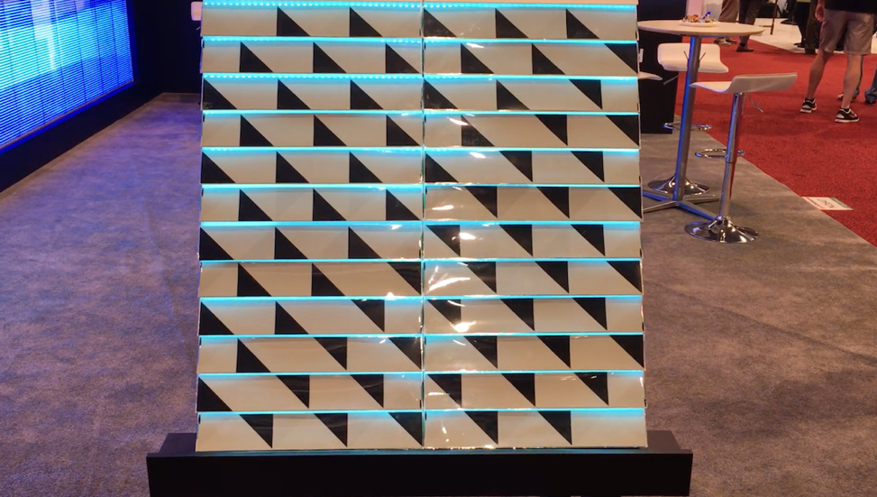
Large E-Ink tile – Video Link

Flexible Displays
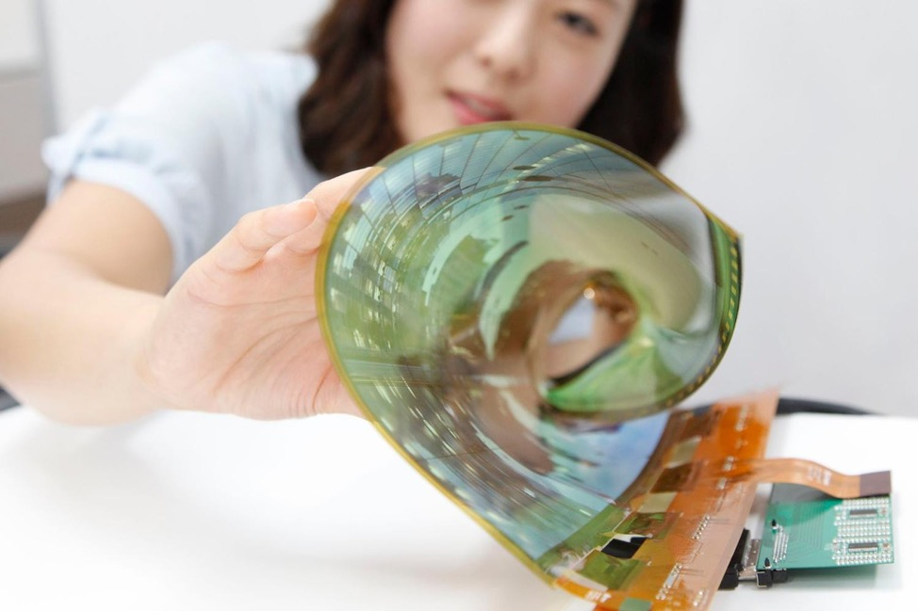
LG Flexible Display - Source
Flexible displays have been appearing in tech news for years, but very few have reached consumers due to their niche uses and currently high cost of production. A few smartphones, such as the Samsung Galaxy Round or Galaxy Note Edge, have these in the form of screens that have a slight wrap around the edges or a curved body. OLED technology is typically used for these flexible displays, although flexible E-ink screens are also being researched. Here is a demo video of a flexible screen.

Making flexible LCD’s isn’t impossible since there are curved TV’s out there, but the cost implications may be huge. OLED, on the other hand, can be manufactured in very thin layers on a plastic substrate. OLED's also emit their own light, so there is no need for an additional backlight. The screens can be bent or rolled a considerable amount, and only one full edge needs to be connected to the display driving electronics. There is also a greater potential for these to be manufactured in unusual shapes other than rectangles.

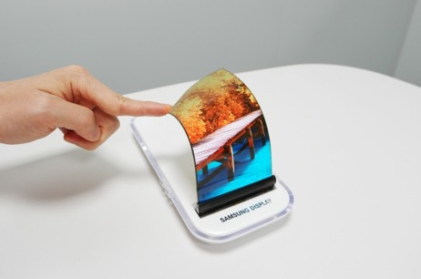
Unfortunately, aside from the smartphones that were mentioned and a few curved TV's, the market demand isn't incredibly high for these yet. Manufacturing plants will need to adjust to suit their specialized production, so the price is still much higher than LCDs. The market will need to be convinced that a flexible display is a must-have item in order to boost production and lower costs, but the use cases aren't incredibly compelling yet. One of the intriguing uses of a flexible display is that it can potentially be utilized as a user interface element. The flex of the screen could be sensed by software and used as a gesture in addition to swipe and tap gestures. We will see more and more about flexible displays in the next few years as the technology continues to advance.
Samsung’s Flexible Display - Source

Laser Projector/Laser Display
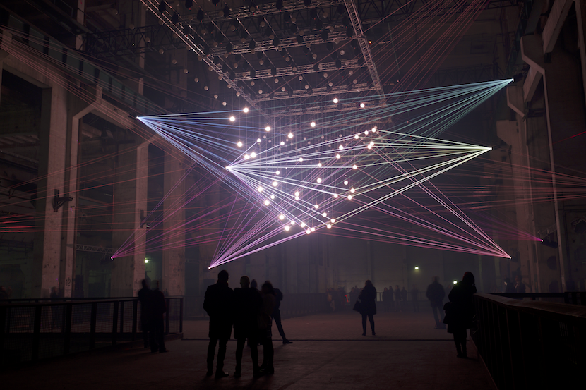
Robert Henke’s Deep Web – Source
Laser projectors have some really unique visual characteristics that make them ideal for the right content and application. Most of them work by shining a combination of different colored lasers (red, green and blue) onto a motorized mirror that moves incredibly fast. They have been around for a while, but due to several factors they aren't used very regularly in art pieces and performances. Here is a thirty minute video from the International Laser Display Association (ILDA) showing a range of different visuals that can be achieved with lasers. They are are understandably confused with other laser video projectors that usually use a more traditional display and lasers as a light source. There are some pico projectors that used lasers as an imaging method and were able to achieve infinite focus, but they are difficult to find these days.

The primary hindrance in working with lasers is that they are quite dangerous. While staring straight into a 10,000 lumen projector may feel uncomfortable, it is not nearly as likely to blind you. A laser light beam is so concentrated that it can cause serious damage by literally boiling the cells in your eyes until they burst and scar. Even a 1 milliwatt laser can cause permanent damage to your eyes if you stare at it, but 5mw and above is where your eye’s natural reflex to blink won’t even protect you - see more details on laser safety here and here. Consumer laser pointers are comparably low powered and will be 1mw to 5mw. Laser projectors on the other hand are going to be 485mW, 1W, 2W or more. Brightness essentially correlates with wattage with these. High wattage beams can be fire hazards or burn the skin if used irresponsibly. It is recommended or required that you use specialized eye protection when working with these lasers because a stray reflection for only a few milliseconds can cause damage. Different states and countries have varying restrictions on the use of lasers in live events and most places require a licensed operator or a variance. The restrictions are typically on which direction the lasers shine, and how far above or away from the audience they should be shining. Some laser projector vendors provide the necessary usage variance when purchasing them.

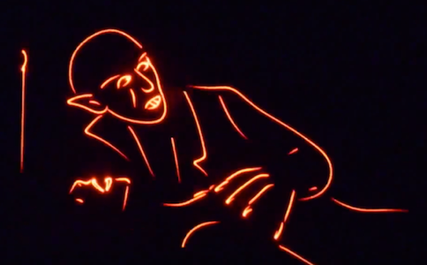
The danger factor is unfortunate because lasers have a very unique aesthetic. The sharpness of their beam gives them a vector quality that is almost impossible to represent with the pixel density available in today’s projectors and displays. The scanning motion of the mirror makes the drawn lines sort of infinitely continuous instead of being comprised of discrete elements. The Vectrex of the 1980's had a similar aesthetic.
Example of an image drawn with a laser projector - Source

This mechanical method of drawing has its limitations in that the mirror can only move so fast and draw so much in a given “frame.” If a laser projector tries to draw an image that is too complex, the image can appear to flicker because it can’t actually draw all of the points needed in a single frame, so its “framerate” drops. This flicker effect is painfully obvious when laser projectors are filmed, which makes them an unlikely choice for something you plan to document. Most laser projectors have specifications on how many points per second (pps) they can draw - some of the low end ones can do 20,000pps or 20kpps, and higher end ones can do double that or more. 20,000 points sounds like a lot, but 20,000 per second means you only get something like 330 individual points per frame if you’re trying to draw at 60fps. This means you have to be smart about your content and economical about where your image complexity is.

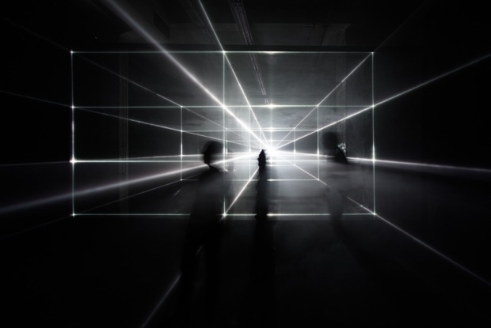
Additionally, since the laser doesn’t scan left to right, top to bottom like the electron beam in a CRT television, it means you can’t just order your points all over the place, send them to the projector, and expect it to work out. Ideally, the beam should move as little as possible to its next point so that the motor isn’t trying to draw one extreme side and then another - the time it takes to move the mirror that far can have a serious impact on its draw speed. This also means that you’ll really only ever see shape outlines on these kinds of projectors, because filling in a shape would take far too many mirror motions and your eye wouldn’t see it as continuous anymore. The motion of the mirror also limits the “throw ratio” of the projected image. The width of the projected image is typically much smaller than a lot of video projectors that you may be used to - this means you need to be much further back from a surface if you want a larger image. The good news is, compared to video projectors, you’re losing a lot less light when you increase the scale of your image. The specs on a laser projector don’t always clearly tell you the expected width, so you will have to put on your math goggles to figure out the size at a given distance.
Vanishing Point by United Visual Artists - Source

The other thing to consider about laser projectors is their contrast and their color reproduction ability. Regular projectors still have issues with their black levels because they are still shining light even when the scene is black, and this lowers their overall dynamic range. Laser projectors don’t have this problem because they only project light where it needs to be, so their lines really pop. However, you’re less likely to have access to a laser projector that can cover a wide color gamut - some cheaper projectors will only give you about 7 colors by mixing red, green and blue lasers. High quality projectors can do a wider range of color mixing. Dimming the beam can also be tricky unless you are using a high quality projector with a good blanking control.

Head mounted displays
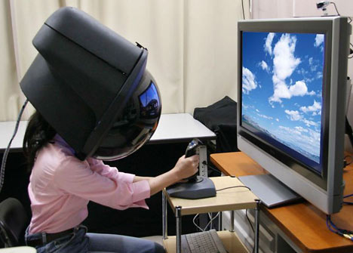
Toshiba’s 2006 Full Dome HMD - Source
Head-mounted displays (HMDs) could have their own article by themselves, but they are worth briefly mentioning here. These displays have been around in some form since at least the 1960s. These can be divided into two types depending on whether they are used for virtual reality, augmented, or mixed
reality.

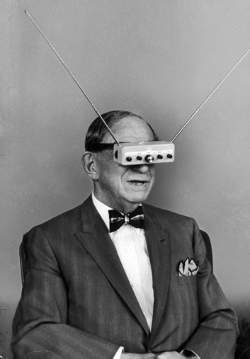
HMDs for virtual reality are typically a standard display (primarily OLED these days) and optics that are strapped to a user's face. Current consumer examples would be the Oculus Rift, HTC Vive and Samsung Gear VR. Software renders a separate image for each eye, and sensors in the headset (or external tracking cameras) allow the software to adjust the rendered camera position to give an illusion of your head being in a virtual space. The brain is extremely sensitive to latency between your head movements and what it expects your eyes to see. If the latency or delay between those two is too high, the sense of immersion is lost and some users can experience motion sickness. To counteract this, the tracking devices and displays are engineered to keep this latency as low as possible. The refresh rate of the display is usually higher than most 60hz monitors, which means that your content must be able to run faster than 60fps as well. The graphical demands of high fidelity virtual reality also means that these will still be tethered to a PC for now (except for the Samsung Gear VR). For AR devices, the computing and display elements are encapsulated in the same device, to allow for more free range wandering.
Hugo Gernsback’s Television Goggles - 1963

HMDs for augmented and mixed reality have a lot of different display methods depending on the manufacturer and the end goal. Eventually, the difference between augmented reality and virtual reality displays may only be a switch or fader that dims out the "real world" as the generated graphics are given more emphasis. Google Glass uses a prism/projector technique. Microsoft Hololens uses an unusual method of edge lit holography or a waveguide element. Magic Leap is rumored to be some kind of retinal projection technique, but very little is known about it at the time of this writing. In addition to sensors like accelerometers and gyroscopes used to track head position, some of these displays use cameras to augment their visuals. By using computer vision techniques, devices like the Hololens are able to track physical objects in front of the user and augment them accordingly. By combining all of these tracking systems, these displays are able to make elements appear 3D since they can render different angles as the user walks around.

Plasma Combustion
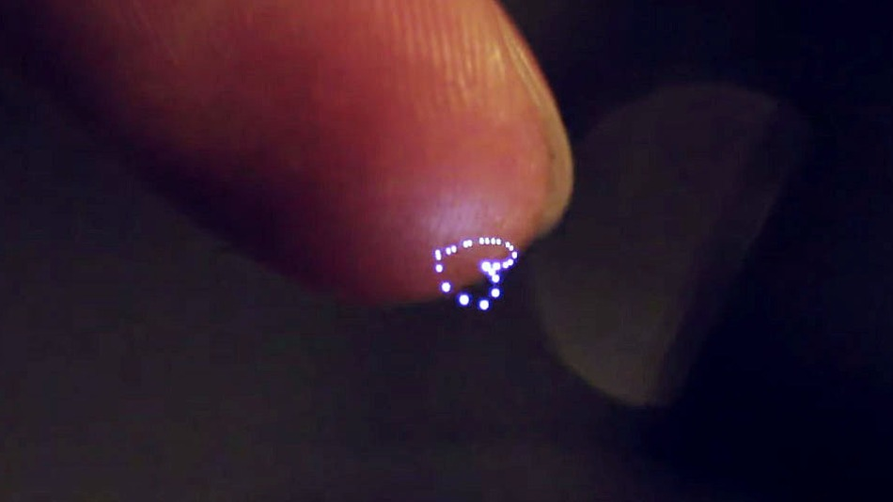
Image from paper Fairy Lights in Femtoseconds - Source

This kind of display acts in a similar way to Volumetric Projection, but it is considerably more dangerous and expensive. There are only one or two companies working on this display type right now, and one is Aerial Burton. There is limited information on how this display actually works, so take my layman’s explanation with a grain of salt. This display technique works by focusing high powered lasers onto a point in space. When the energy at that point gets hot enough, the air molecules get ionized and release some photons. Aside from ionized plasma, fluorescence is one, and cavitation is another when involving a fluid medium. Here is a video of the Aerial Burton display in action.
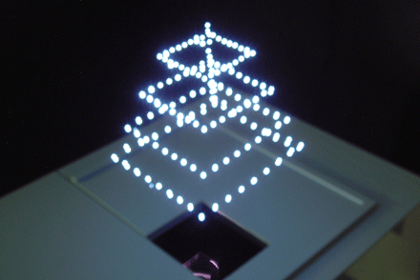
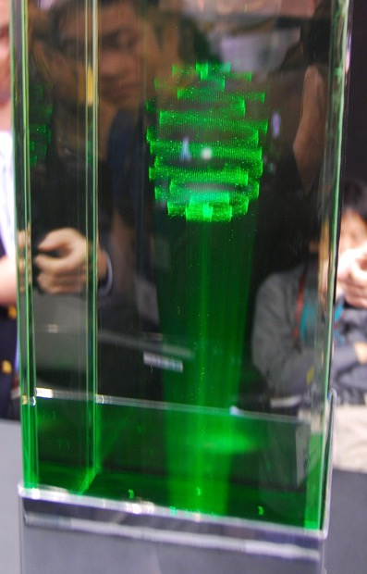
Two forms of Aerial Burton’s displays – one with a fluid based medium and one based entirely in air – Source
This display unfortunately has many drawbacks that are similar to those of a laser projector. They still work by moving a mirror very quickly, so there is a limited number of points that they can draw at a given time. There is also an added crackling noise component because of the tiny explosions needed to make the visuals. These tiny explosions can also emit an ozone gas that can be potentially harmful if used in an enclosed space.

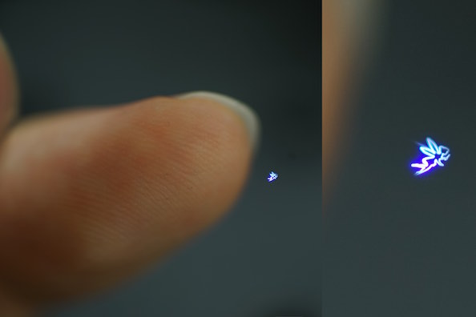
Another set of researchers in Japan have been working on a much smaller implementation of this same technique that they are calling the Fairy Lights display system. The primary difference is that this version is touchable. By firing the lasers much faster than the Aerial Burton method, the images are smaller and not as bright, but much safer. The tangible element can be used as an additional cue for interaction with the display. They still have similar drawbacks related to visual fidelity (number of dots per second) and added popping noise (their paper says about 22dB of noise is added when using the display). Here is a video featuring some of the interactions and visuals that can be produced.

Image from paper on Fairy Lights in Femtoseconds - Source

Physical/Mechanical/Kinetic Displays
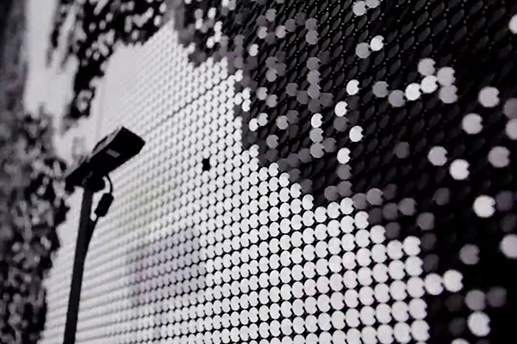
Image of a Flip-dot Display - Source

Some artists also work with display surfaces that don’t emit light or use optics at all. Most of these displays are entirely custom and work with a massive array of motors or other electromechanical means. Haptic communication is another big one that is being explored with this type of "display." The line between sculpture and information display is really blurred with these, so its tough to quantify exactly what falls into a display and what is just a lot of motorized elements.

There are some commercially available physical displays such as Flipdot displays. There are just a few vendors for these in the world. These work by using electromagnets to flip a metal disk that has different colors on each side. They are capable of fairly simple graphics since they are essentially just binary pixels. There have been a few installations that have figured out how to make them switch fast enough to do full video representations. There is also an audio component to having so many elements mechanically flipping at once, as in this video of a large 588x216 resolution screen. There is also the potential to develop them to have the discs spin completely 360, which when combined with a variable speed, they would be able to represent grayscale values instead of just on-off.

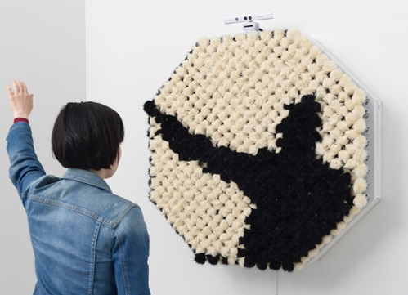
There are a ton of other variations on this same concept that either use an array of motors or electromagnets. The artist Daniel Rozin has been exploring this concept for years with a ton of different materials - trash, wood, penguin dolls, metal balls - etc. There are also pieces that take this concept into a third dimension and use elements suspended on wires to represent limited forms in 3D. The same concept has been applied to a fleet of drones that were used to render low resolution volumes.
Danny Rozin’s PomPom Mirror - Source

These physical displays continue to get more sophisticated as the years go on. This display was created out of special spools of thread that had a gradient of colors on them. By knowing the motor's position, the software was able to know which color was currently on the front of the display, allowing them to render pixelated portraits of user generated photos. This one called the Megafaces Pavilion was made of thousands of actuated LED elements that were used to render people's faces for the 2014 Sochi Olympics.

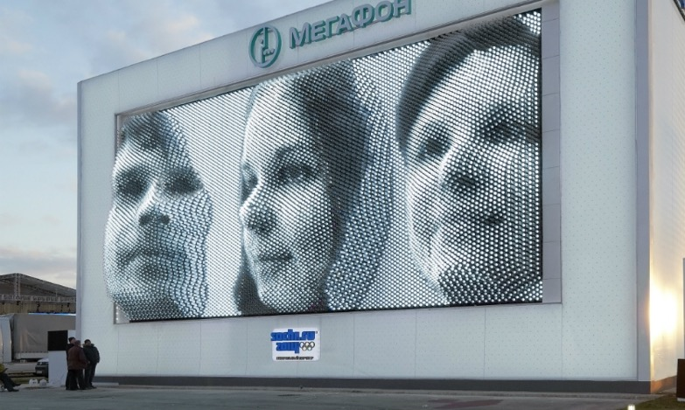
MegaFaces Pavilion for the 2014 Sochi Olympics - Source
As mentioned, these kinds of physical actuated displays are also used in conjunction with projection to add haptics as another layer of interaction and collaboration. The inFORM from MIT has been the classic example of this for the last couple years. Some researchers are even working on ways to use electrical signals to simulate textures on touch screens - but a full writeup on the future of haptics and displays is one for another article :)

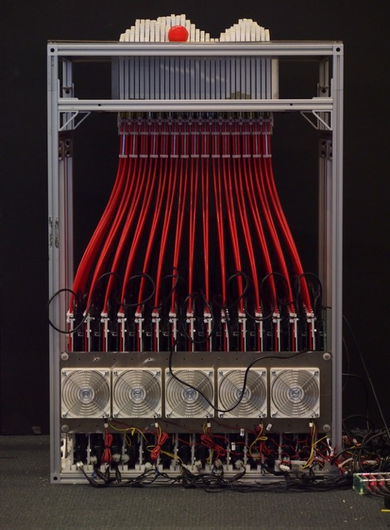
MIT’s inform Haptic Display - Source

Closing Notes

These are just a few of the possible options for display types and techniques of working with light. Once you find a research paper on one, there are a million other paths in the references of that paper. I hope this gave you a good idea of the range of amazing technologies out there - from the DIY $5 option to the theoretical and fanciful. There are other effects we didn't explore in detail like stereoscopic displays for home 3D movie viewing, lenticular effects and many more. There are also a lot of technologies that never took off, either for reasons of cost, complexity, or ownership. Things like CamFPD’s wedge display, or Electrowetting displays (similar to e-ink) were ones that had great commercial potential only 10 years ago, but never ended up taking off for one reason or the other. Some techniques are quite old and were never acquired as intellectual property and will eventually be available in the public domain. There are whole conventions devoted to advancements in display technology, but much of it never reaches the general public or the artistic community. Lots of great options, ripe for use or modification. The more we experiment and use these technologies, the sooner we’ll get to advance the ones on the fringe. If interest in these alternative displays increases, they will become more normalized and costs will come down, opening the door for even more experimentation.

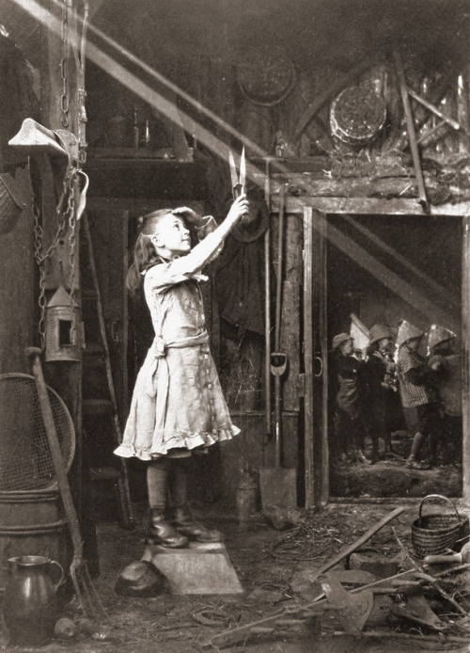
We'll be seeing a lot more display developments in the next few decades, so keep your eyes open and see which ones might be a good fit for your artistic vision.
Image: Adam Diston - Cutting a Sunbeam 1886

Acknowledgments
Thanks to a ton of people for taking the time to read this and give me comments and extra content, it is truly appreciated. A partial list: Kyle McDonald, Elliot Woods, Deborah Johnson, Matthew Ward, Jesse Garrison, Matt Parker, Ali Tan Ucer, Dan Moore, Sean Kean, Jamie Zigelbaum and others.

Appendix A

DIY Notes to Remove the Polarizer from your Monitor
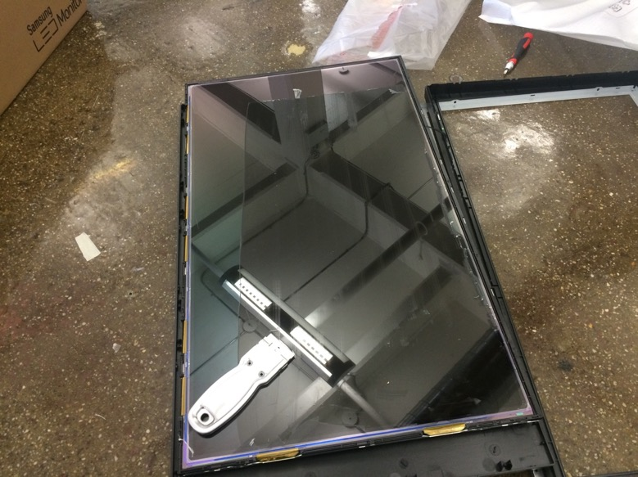
Image of attempting to slowly scrape the film off of a monitor with a razor blade

Since these screens aren’t typically manufactured like this, you will have to open the screen up and remove the polarization layer off yourself. Similar to my notes on making your own transparent screen, this involves opening up the screen and potentially breaking your monitor casing, electrocuting yourself, or cracking the delicate LCD. I broke 2 screens before I got this right, and every manufacturer applies their polarization film differently. Sometimes you can peel it right off, and sometimes it will be applied with adhesive and require a few hours with a razor blade and some acetone to dissolve the adhesive. The film tends to have a “grain” to it, so if you start on a corner and that corner of the film snaps off, try the opposite corner. Pull very very slowly - one wrong move, and you’ll crack the glass holding the liquid crystal in place. The film itself it also very sharp - paper cut style - I sliced my hands up more than once. Patience is the name of the game.

Once you have the film off the screen, you may be saying “Hey! What gives - this film is all blurry!” The explanation is that manufacturers combine the polarization layer with a diffusion layer to improve viewing angles, but this makes the film difficult to use if it is not sitting directly on top of the screen. However, there are tons of online vendors for sheets of linear polarization film that do not have diffusion. If you’re not in the DIY spirit or need to get this done on a massive scale, there are screen vendors listed in the references section that do have the ability to remove polarization film from very large displays and are closer to the supply chain than a consumer could get.

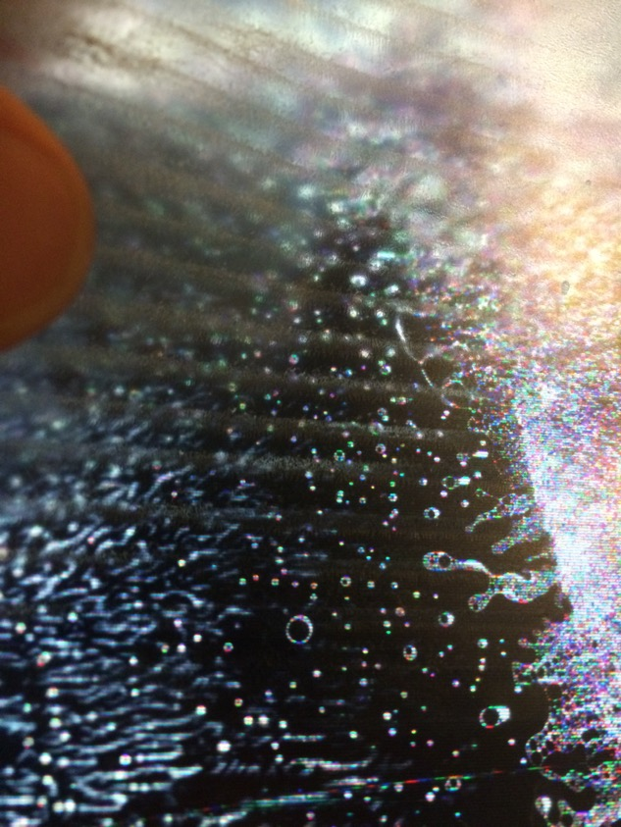
Image of my failed attempt at removing the polarizer – moved too quickly and cracked the glass

Appendix B

Notes on DIY Transparent screens

You can modify an existing LCD monitor to be transparent by opening up the monitor and removing the backlight yourself. Insert boilerplate copy about how you should not attempt this without understanding that you may completely break your screen or cause personal injury/electrocution and the author assumes no responsibility - please be cautious and safe.
Speaking from personal experience, this is a difficult modification to perform on monitors from the factory, quite simply because they are not designed to be used this way. I have done this to 4 or 5 different LCD screens and there is a tremendous amount of variability in how different manufacturers assemble their screens, so there is not a consistent guide that would work for each screen. You may be able to open the screen up, but that may require breaking the internal plastic tabs that hold it together - ensuring that you can’t quite put it together again. You must also go very slowly to ensure you aren’t going to crack the screen or rip or damage the delicate electronics inside.

Once you have it opened up, the backlight and LCD screen are often sandwiched together with a metal frame that must be carefully wedged off. One of the long edges of the LCD panel is going to have a very fragile thin plastic flex cable that traverses the whole side. This flex cable essentially controls each column of pixels individually, so if any part of it gets damaged, you may lose that part of the screen or the screen entirely. Removing this element and its PCB from the rest of the case and the backlight is probably the hardest part of the whole process. Additionally, some screens have an additional diffusion film that is bonded to their polarizer for the purpose of improving viewing angles – unfortunately, this layer makes content behind the screens get completely blurred out.

They used to sell things like transparent LCD's before they could make affordable high definition LCD panels that can fit in today's projectors. They were sold as bulky glass panels that could be connected to a computer and placed on top of an overhead projector.

Other resources, oddballs, optics, and more

Mist/Water Vapor/Fabric/Material:
- Fog Screen
- Heliodisplay
- io2 Technology Mid Air Display
- Periscopista — interactive mist installation
- Tsunami Water Screen
- Silicon Rod Projection Surface
- Aquatique Vendor of Water Curtains
- LCI Jet Screen
- DIY Fog Screen
- Projection on Half Silvered Mirror
- Colloid Bubble Film Display
- Fog screen with Head Tracking
- Interactive Fog Display with tracking
- Holovect 3D Projection display

Pepper’s Ghost
- Glimm Displays Film Vendor

Volumetric Image Displays:
- Volumetric/Computational Display Survey PDF
- Wikipedia Entry
- Hackaday list
- Long Exposure Photo Volume
- Water and Oil Surfactant
- voLumen
- Hublot Sphere
- Holovizio
- Sony RayModeler
- Volumetric Display based on Mylar Beam Splitter and LED Backlit LCD
- Patent on varifocal beamsplitter volumetric display
- 360 Light Field Display
- Multiple projector and rotating screen display
- Overview of other volumetric displays
- Paper on progress in Volumetric Displays
- Actuality Systems Overview
- List of Publications from Gregg Favalora on Volumetric/Autostereoscopic displays

Layered Volumetric Displays:
- Lumarca
- Tensor Display
- Layered LCD with Polarization Layers
- Layered Pepper's Ghost example
- Crayolascope
- MIT Tensor Display
- Puredepth
- DepthCube Info
- LightSpace Tech - Maker of DepthCube

Volumetric Projection:
- Light Barrier by Kimchi and Chips
- Birth of light by WOW
- 3 projector rabbit

Non Realtime Volumetric Displays:
- Kimchi and Chips Lunar Surface
- Marshmallow Laser Feast’s McLaren Launch
- Berg’s Making Future Magic

Laser Projector:
- Kvant Lasers
- United Laser
- Phaenon projector
- X-Laser Projectors
- Guide to Laser Shows
- Nightsun Specialized Illuminators

Lenticular/Light Field:
- Leia Inc. Light field Display
- Nvidia Near-Eye Light Field Display
- 2007 Exhibition on Stereoscopic Displays
- Parallax Barrier Display
- Compressive Light Field Projector
- Studio Roosegarde - Beyond Lenticular
- Multilens display for multiple views

Flexible Displays:
- Problems Facing Flexible Display Manufacturing
- Flexible OLED overview site
- Holoflex Flexible 3D Display

Head Mounted Displays:
- Toshiba Head Mounted Display 2006

Mechanical/Physical Volumetric Displays:
- DIY Helical Display
- Lumarca
- Perspecta Systems Wired Article
- Perspecta Systems Article
- 3D printed Helix Display

E-Ink Displays
- 32" Electronic paper development kit
- Notes on E-Ink Refresh Rate
- Dasung 13.3" E-Ink/Paperlike Display for $1300

Haptic Displays:
- MIT inForm
- Ultrasound Haptic Display

Transparent LCD References:
- Custom Display Manufacturer based in Korea
- Transparent OLED 2.0" Panel Vendor
- Iris by Hybe
- Potential Vendor: Crystal Display Systems
- Hypebox Transparent LCD product
- Transparent LCD Bus to Mars Lockheed Martin Project
- Evoluce for Transparent LCD and OLED
- CDS Transparent Faq
- Planar Transparent OLED
- Stimulant writeup on Planar Transparent OLED
- Pro Display Vendor
- DIY Screen Removal
- HybeBox pre-built transparent LCD display box
- "Transparent" LED Wall (spaced out slats)
- Hypersonic - Patterned by Nature

LCD with Modified Polarizing layers:
- Polarizing Filter Source - API Optics
- Polarized Light Explanation Video
- Brewster’s angle
- Lynx Modified Polarizer Advertisement
- Flavien Théry
- Flavien Théry Artist Page
- Simulacra by Smigla Bobinski
- Ryo Kishi
- Dual Polarizer Layers

Physical Mechanical References:
- Random international Light Points
- Sand Drawing with Magnets - Sisyphus
- Studio Roosegarde - Flow - Fan Display

Miscellaneous/Unusual/Light Art:

- Large Lenticular Print
- Xyloband – Crowd Led lights synced by IR/RF
- Offline – Syncing Multiple Phones together for a synchronized light show
- Another Great survey of various display tech
- Microlens Array Example
- Paramagnetic/Electroluminescent Paint
- 3D Printed Optics Lightguide
- ClaytricSurface Haptic Deformable Screen
- Spatial Light Modulator Wiki
- Fiber Scanned Displays
- Edge Lit displays
- Oddball Television History Links
- Measuring luminance of a surface
- Dynaflash High Speed Projector
- Quantum Dots
- Liquavista e-ink
- Color e-Ink Info: Interferometric Modulator Display
- Qualcomm's Mirasol Color e-Ink technology
- Good Resource for Hacking CRT's
- Printed Optics
- Cinema Snow Globes
- Encoded Mirrors by Florian Born
- Vibrating projection lens and lenticular combination
- Solace by Nicky Assmann
- 360 Video Rigs
- Project FEELEX Haptic Research
- RePro3D Parallax Display
- Cylindrical Lightfield Display
- HaptoMirage

